Test Case: tc001_SPX_Dev5_Crear_Solicitud_Articulo_Almacen
Step 1 - Enter username and password and click to button Enter : Credentials Entered
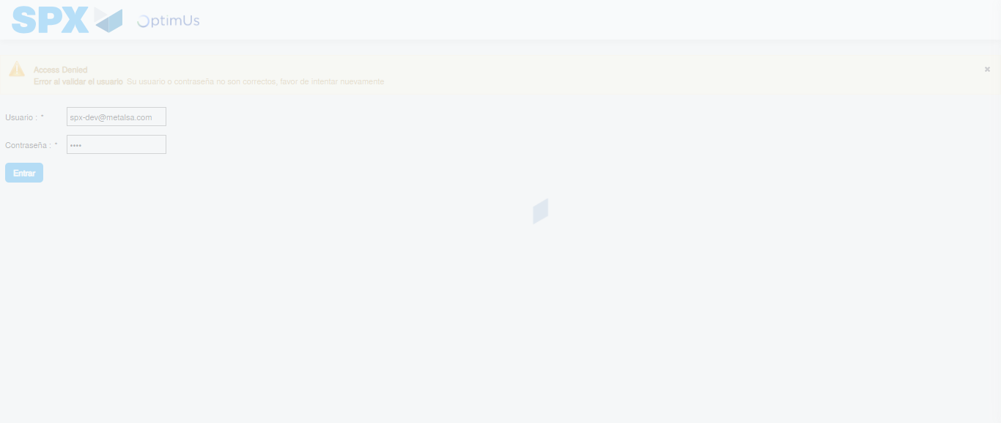Image file-name: QC_Testing-tc001_SPX_Dev5_Crear_Solicitud_Articulo_Almacen-1787857174765

Step 2 - Select to UEN and Access to Request for a New Inventory Item : UEN Correctly selected and Correct access
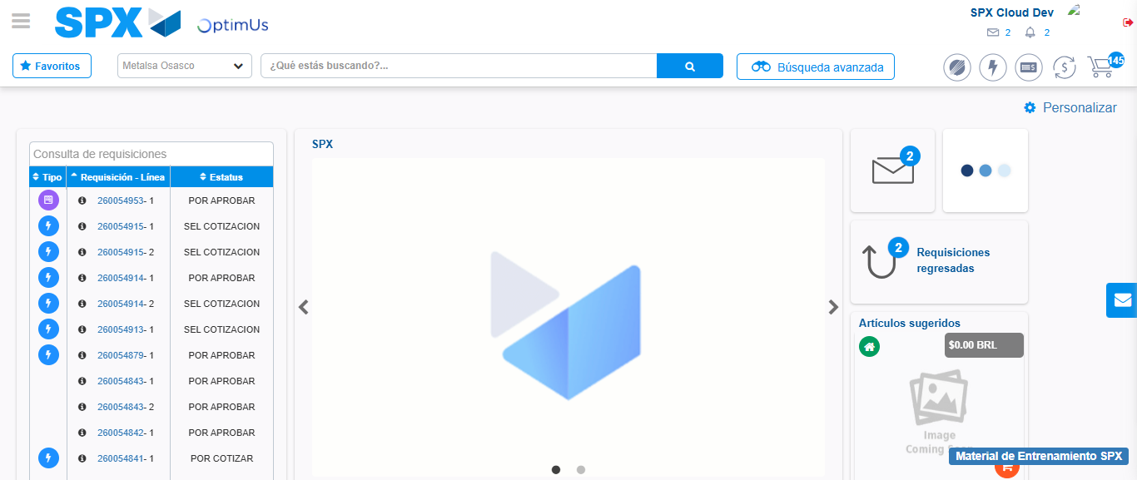Image file-name: QC_Testing-tc001_SPX_Dev5_Crear_Solicitud_Articulo_Almacen-1787857200832

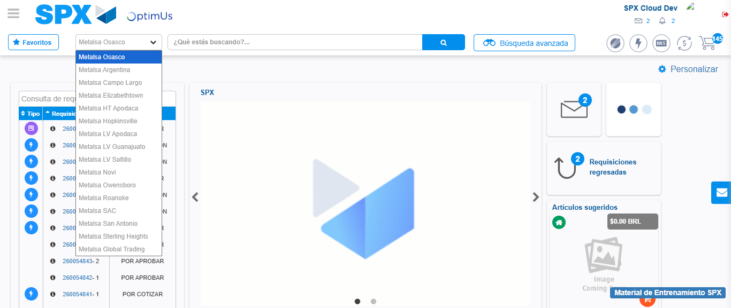Image file-name: QC_Testing-tc001_SPX_Dev5_Crear_Solicitud_Articulo_Almacen-1787857201639

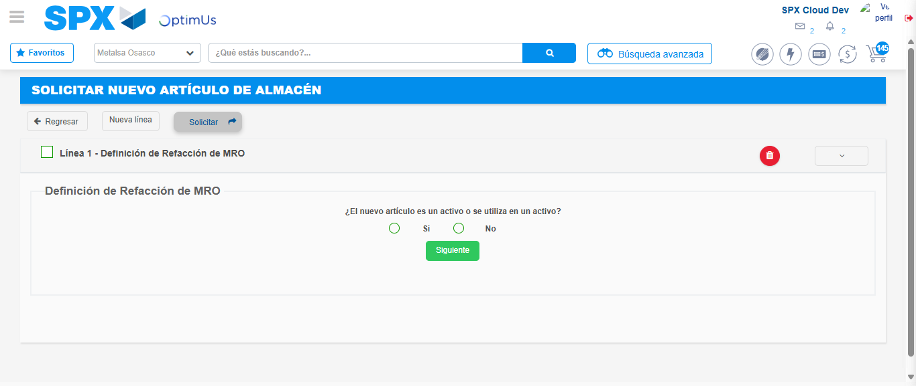Image file-name: QC_Testing-tc001_SPX_Dev5_Crear_Solicitud_Articulo_Almacen-1787857224319

Step 3 - Select options first section : Options seleted correctly
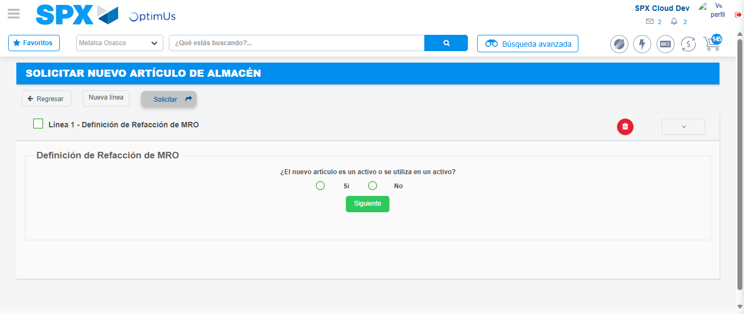Image file-name: QC_Testing-tc001_SPX_Dev5_Crear_Solicitud_Articulo_Almacen-1787857224633

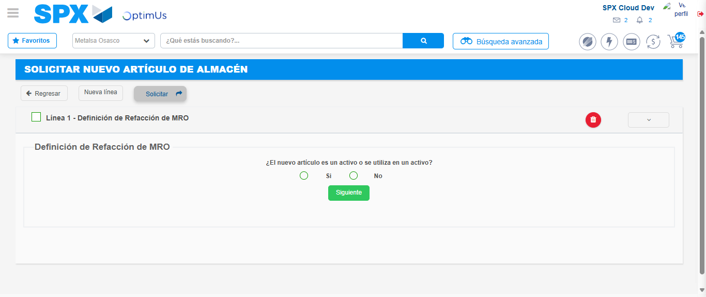Image file-name: QC_Testing-tc001_SPX_Dev5_Crear_Solicitud_Articulo_Almacen-1787857224907

Step 4 - Select options section location and position: Options seleted correctly
Image file-name: QC_Testing-tc001_SPX_Dev5_Crear_Solicitud_Articulo_Almacen-1787857224633

Image file-name: QC_Testing-tc001_SPX_Dev5_Crear_Solicitud_Articulo_Almacen-1787857224907

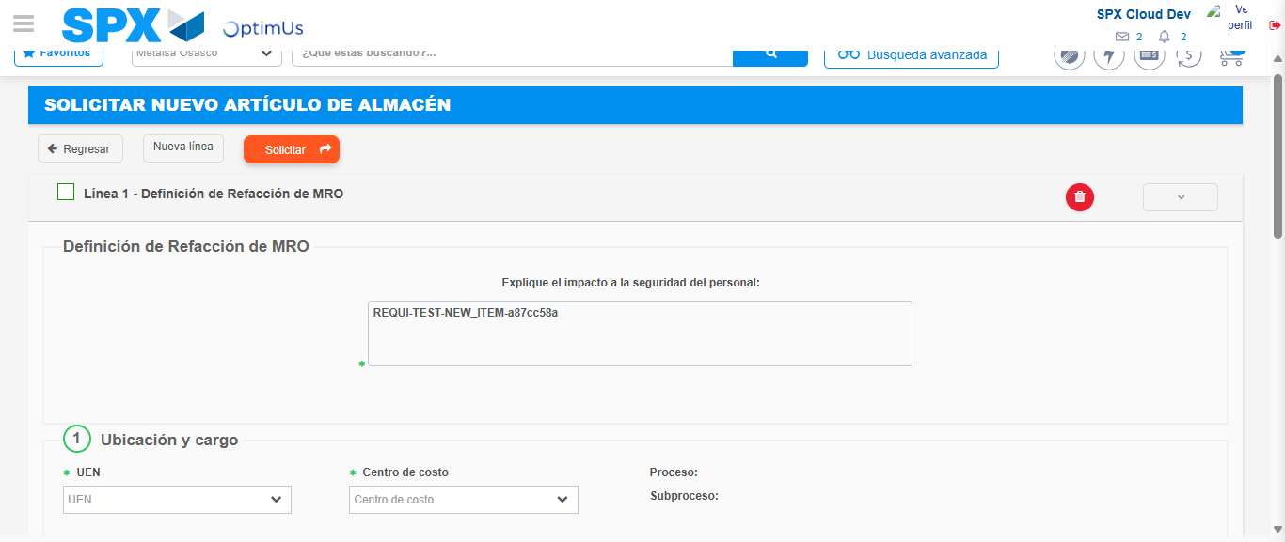Image file-name: QC_Testing-tc001_SPX_Dev5_Crear_Solicitud_Articulo_Almacen-1787857232344

Step 7 - Return to Main Page SPX : Return to Main Page SPX
Image file-name: QC_Testing-tc001_SPX_Dev5_Crear_Solicitud_Articulo_Almacen-1787857200832

Image file-name: QC_Testing-tc001_SPX_Dev5_Crear_Solicitud_Articulo_Almacen-1787857201639

Image file-name: QC_Testing-tc001_SPX_Dev5_Crear_Solicitud_Articulo_Almacen-1787857224319

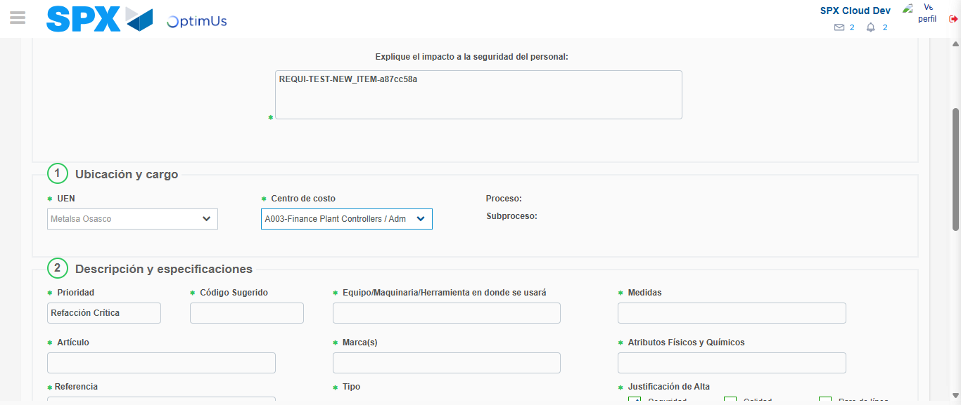Image file-name: QC_Testing-tc001_SPX_Dev5_Crear_Solicitud_Articulo_Almacen-1787857237599

Image file-name: QC_Testing-tc001_SPX_Dev5_Crear_Solicitud_Articulo_Almacen-1787857237861

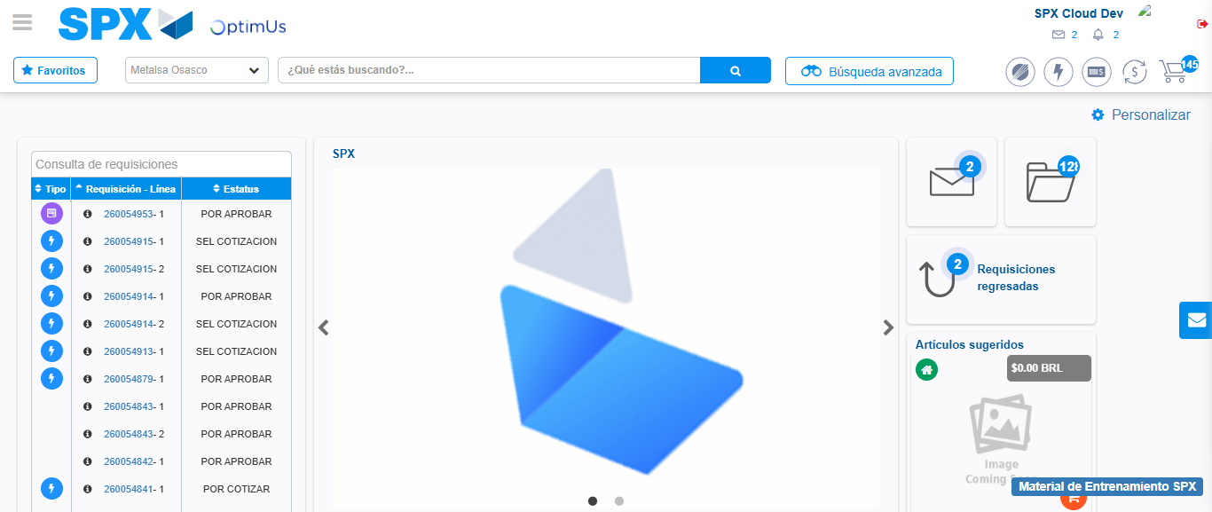Image file-name: QC_Testing-tc001_SPX_Dev5_Crear_Solicitud_Articulo_Almacen-1787857259392

Step 8 - Log Out : Log Out SPX
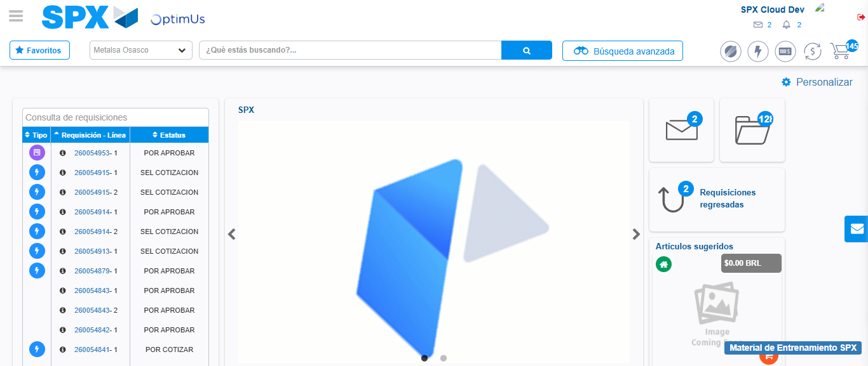Image file-name: QC_Testing-tc001_SPX_Dev5_Crear_Solicitud_Articulo_Almacen-1787857259841

